

**FINAL YEAR PROJECT REPORT**

**BS (COMPUTER SCIENCE)**

**MOODTUNES**

**Speech emotion recognition-based music recommendation system**

**SUBMITTED BY**

**ABDUL MAJID 47390**

**SYED SAAD AHMED 44921**

**MUHAMMAD YASEEN 47003**

**HASSAN ALI 44470**

**SUPERVISOR**

**SOPHIA AJAZ**

**COORDINATOR**

**DR. ATIYA MASOOD**

**FACULTY OF ENGINEERING, SCIENCE AND TECHNOLOGY**

**IQRA UNIVERSITY, KARACHI**

**MARCH 2023**



**FINAL YEAR PROJECT REPORT**

**BS (COMPUTER SCIENCE)**

**MOODTUNES**

**Speech emotion recognition-based music recommendation system**

**SUBMITTED BY**

**ABDUL MAJID 47390**

**SYED SAAD AHMED 44921**

**MUHAMMAD YASEEN 47003**

**HASSAN ALI 44470**

**SUPERVISOR**

**SOPHIA AJAZ**

**COORDINATOR**

**DR. ATIYA MASOOD**

**FACULTY OF ENGINEERING, SCIENCE AND TECHNOLOGY**

**IQRA UNIVERSITY, KARACHI**

**MARCH 2023**

# **DECLARATION**

I hereby declare that the work has been done by myself to fulfill the requirement of the BS (Computer Science) and no portion of the work contained in this report has been submitted in support of any application for any other degree or qualification of this or any other university or institute of learning. I hereby further declare that in the event of any infringement of the provision of the Act whether knowingly or unknowingly the university shall not be liable for the same in any manner whatsoever and undertake to indemnify and keep the university indemnified against all such claims and actions.

**_________________________**

**© ABDUL MAJID [47390]**

**_________________________**

**© SYED SAAD AHMED[44921]**

**_________________________**

**© MUHAMMAD YASEEN [47003]**

**_________________________**

**© HASSAN ALI[44470]**

**ACKNOWLEDGEMENT**

I would like to express my sincere gratitude to Ms. **Sophia Ajaz** for their invaluable guidance, support, and encouragement throughout the course of this project. Their expertise, patience, and willingness to share their knowledge have been instrumental in helping me to develop my skills and complete this project successfully.

I would also like to thank **Dr. Atiya Masood** for their contribution to this project, whether it be in the form of feedback, resources, or inspiration. Their support has been invaluable in shaping my understanding of the topic and providing me with the motivation to continue working towards my goals.

Finally, I would like to express my gratitude to my friends and family who have supported me throughout this process. Their love, encouragement, and unwavering support have been a constant source of strength and inspiration, and I am grateful for their presence in my life.

Thank you all for your support and encouragement throughout this journey.

# **ABSTRACT**

The proposed system provides a novel approach to music recommendation by utilizing speech emotion recognition to recommend music that matches the user's current emotional state. The system has the potential to simplify the music selection process by reducing the time and effort required to search for the right music for a particular mood.

This project aims to develop a Speech Emotion Recognition based Music Recommendation System. The proposed system utilizes machine learning techniques to recognize users' current emotional state and recommend music accordingly. The system consists of two main components, the backend developed using Python, and the frontend developed using Flutter.

The backend, developed using Python, uses the emotional state and preferred music genres to recommend a curated playlist. The system allows users to provide feedback on the recommended playlist, enhancing the recommendation algorithm over time. The frontend, developed using Flutter, provides an intuitive interface for users to input their preferred music genres, view their real-time emotional state, and play the recommended playlist directly in the app

We have approved this manuscript for submission and presentation as fulfillment of Bachelor of Computer Science.

_______________________________

Supervisor: Ms. Sophia Ajaz Date: 16-03-2023

_______________________________

Project Coordinator: Dr. Atiya Masood

# **Table of Contents**

**DECLARATION** 2

**ABSTRACT** 4

**Table of Contents** 6

**List of Tables** 9

**List of Figures** 10

**CHAPTER 1** 11

**1.1 Introduction/Background** 11

**1.2 Problem Statement** 12

**1.3 Motivation** 12

**1.4 Project Objective** 13

**1.4.1 Research Objective** 14

**1.5 Challenges** 14

**1.6 Structure of the Report** 15

**2. Technology Background** 16

**2.1.1 Python** 16

➢ **Scikit-Learn:** 17

➢ **TensorFlow:** 17

➢ **Librosa:** 18

**2.1.2 Flutter** 18

**2.1.3 Firebase** 19

**2.2 Literature Review** 20

**3.1 Introduction** 22

**3.2 Project Plan** 22

**3.3 Functional Requirement** 23

**3.4 Non-Functional Requirement** 23

**3.5 Hardware Requirements:** 24

**3.6 Summary** 25

4.1 Introduction 25

4.1 ERD 26

4.2 Data Flow Diagram 26

**4.3 Use Cases** 27

Summary: 31

5.1 Introduction: 31

5.2 Prototype Design: 32

6.1 Introduction: 41

6.2 Test Cases: 41

6.2.1 Test Case 1: 41

6.2.2 Test Case 2: 42

6.2.3 Test Case 3 43

**6.2.4 Test Case 4:** 43

**6.2.5 Test Case 5:** 44

**6.2.6 Test Case 6:** 45

**6.2.7 Test Case 7:** 45

**6.2.8 Test Case 8:** 46

**6.2.9 Test Case 9:** 47

**6.2.10 Test Case 10:** 48

**6.2.11 Test Case 11:** 48

**6.2.12 Test Case 12:** 49

**6.2.13 Test Case 13:** 50

**6.2.14 Test Case 14:** 51

**6.2.15 Test Case 15:** 51

**6.2.16 Test Case 16:** 52

6.3 Summary 53

**7.1 Introduction** 54

**7.2 System Limit and challenges** 54

**7.3 Future Wrok** 55

7.4 Conclusion 56

Business Canvas: 58

Introduction: 59

1. Getting Started: 59

3. Home Screen 60

4. Emotion Recognition 60

5. Library 60

6. Settings 61

7. Troubleshooting 61

8. Conclusion: 61

# **List of Tables**

Table 1: Sign Up ........................................................................................................................ 17

Table 2: Login ........................................................................................................................... 18

Table 3: Voice Input…… .......................................................................................................... 19

Table 4: Emotion Recognition................................................................................................... 20

Table 5: Display emotion Result................................................................................................ 21

Table 6: Generate Playlist ..........................................................................................................22

Table 7: Prototype 1 .................................................................................................................. 24

Table 8: Prototype 2 .................................................................................................................. 25

Table 9: Prototype 3 ................................................................................................................. 26

Table 10: Prototype 4 ................................................................................................................ 27

Table 11: Prototype 5 ................................................................................................................ 28

Table 12: Prototype 6 ................................................................................................................ 29

Table 13: Prototype 7 ................................................................................................................ 30

Table 14: Prototype 8 ................................................................................................................ 31

Table 15: Prototype 9 ................................................................................................................ 32

Table 16: Prototype 10 .............................................................................................................. 33

Table 17: Prototype 11 .............................................................................................................. 34

Table 18: Prototype 12 .............................................................................................................. 35

Table 19: Prototype 13 .............................................................................................................. 36

Table 20: Prototype 14 .............................................................................................................. 37

Table 21: Prototype 15 .............................................................................................................. 38

Table 22: Prototype 16 .............................................................................................................. 39

Table 23: Test case 1 ................................................................................................................. 40

Table 24: Test case 2 ................................................................................................................. 41

Table 25: Test case 3 ................................................................................................................. 42

Table 26: Test case 4 ................................................................................................................. 43

Table 27: Test case 5 ................................................................................................................. 43

Table 28: Test case 6 ................................................................................................................. 44

Table 29: Test case 7 ................................................................................................................. 45

Table 30: Test case 8 ................................................................................................................. 46

Test case 9 ................................................................................................................................. 46

Table 32:..................................................................................................................................... 49

Table 33: ……………………………………………………………………………….……....49

Test case 3 ................................................................................................................................. 50

Table 37: Test case 15 ............................................................................................................... 50

Table 38: Test case 16 ............................................................................................................... 51

# **List of Figures**

Figure1:Project Plan ................................................................................................. 11 Figure 2: Gantt Chart ................................................................................................ 12 Figure 3: DFD ........................................................................................................... 14 Figure 4: Data Flow …………………………………………………………….…..15 Figure 6: Entity Relationship Diagram ..................................................................... 16 Figure 7: Splash Screen ............................................................................................ 16 Figure 8: Sign Up Use case ...................................................................................... 17 Figure 9: Login Use case .......................................................................................... 18 Figure 10: Microphone Access ................................................................................. 19 Figure 11: Voice Input Use case ............................................................................... 20 Figure 12: Emotion Recognition Use case ................................................................ 21 Figure 13: Generate Playlist Use case ....................................................................... 22

Figure 20: Logout Window ....................................................................................... 27

# **CHAPTER 1**

## **1.1 Introduction/Background**

Music has always been an integral part of human life. It has the ability to affect and alter our emotions, behavior, and even physiological responses. The impact of music on our emotions is so profound that it is often used as a tool for mood regulation, relaxation, and motivation. This is why music has been used in various applications such as therapy, entertainment, and even education. In recent times, the use of technology has made it possible to create music systems that can detect emotions and recommend music based on them.

Speech, like music, also has emotions embedded in it. The tone, pitch, and pace of speech can convey different emotions, such as happiness, sadness, anger, and more. By detecting these emotions in speech, we can understand the emotional state of the speaker. This has led to the development of speech emotion recognition technology, which is being used in various applications such as speech therapy, customer service, and even security.

Combining the ability to detect emotions in speech with the impact of music on our emotions has led to the development of a speech emotion recognition-based music recommendation system. By analyzing the emotional content of speech, the system can recommend music that matches the user's current emotional state. This can be particularly helpful in situations where users may not be able to articulate their emotions or may not know what kind of music would be appropriate for their mood.

In this paper, we will be discussing the development of such a system. We will explore the use of machine learning to detect emotions in speech and the use of this detection to recommend music that matches the user's current emotional state. We will also discuss the development of the system's user interface, which aims to provide an intuitive and engaging experience for usersto interact with the system.

The purpose of this system is to ease the process of finding the right music for the mood, making it effortless for users to discover new songs that resonate with their current emotional state. This technology has the potential to revolutionize the music industry and provide a unique listening experience that is tailored to the user's current emotional state.

## **1.2 Problem Statement**

The problem addressed in this paper is the difficulty that individuals often face when trying to find music that matches their current emotional state. While music has been shown to have a significant impact on a person's emotional state, the process of manually searching for and selecting music that matches one's mood can be time-consuming and frustrating. Additionally, many people may not be aware of the emotional content of the music they are listening to or may not have the vocabulary to accurately describe their current emotional state. Despite the availability of various music recommendation systems in the market, there is still a lack of personalized curation based on the user's current emotional state and their preferred music genres. Existing systems often provide generic playlists that may not match the user's current mood or musical taste. This creates a need for a more advanced and personalized system that can recommend music based on both the user's emotion and their personal music preferences.To address these challenges, we aim to develop a speech emotion recognition based music recommendation system that uses machine learning to detect the user's emotional state from their speech and recommends music that matches their current mood.

## **1.3 Motivation**

The motivation behind this product stems from the potential benefits it can offer to individuals in their daily lives. The ability to recognize and respond to emotions is a fundamental human skill that allows individuals to navigate social situations effectively. Music has long been recognized as a powerful tool for influencing and expressing emotions, and the combination of music and emotion recognition technology can offer a unique opportunity to improve individuals' well-being.

Additionally, the current market offerings for music recommendation systems do not take into account the user's emotional state, resulting in generic recommendations that may not be relevant to the user's current mood. This creates a gap in the market for a music recommendation system that takes into account both the user's preferred music genres and their emotional state, offering personalized recommendations that are tailored to the user's individual needs. By addressing this gap in the market, our product has the potential to improve the music listening experience for individuals, providing them with a more enjoyable and meaningful experience.

Moreover, the development of such a product can contribute to the field of emotion recognition and machine learning, showcasing the application of these technologies in a real-world context. As the field of machine learning continues to evolve, there is an increasing interest in exploring its potential applications in various industries. By developing a product that utilizes machine learning to recognize emotions and generate personalized music recommendations, we can contribute to the ongoing research and development in this field. Additionally, the product has the potential to provide insights into the effectiveness of using machine learning in real-world scenarios, offering opportunities for further research and development.

## **1.4 Project Objective**

The primary goal is to help businessmen coordinate their schedules, which includes

meetings, monthly events, weekly functions, and a calendar management system. All

businessmen will be able to manage their full 365-day year with our web application. This will

also cover their meetings, business promotions, product launches, software launches, and

management of new business branch openings. Task management may be readily managed

according to a set timetable, and many offers meetings and significant events can be quickly

managed

* To develop a speech emotion recognition system that can accurately detect emotions from speech.
* To develop a music recommendation algorithm that can generate curated playlists based on the user's detected emotional state and personal music preferences.
* To integrate the speech emotion recognition and music recommendation algorithms into a single software system.
* To develop an intuitive and engaging user interface for the software system that allows users to easily interact with the emotion detection and music recommendation features.
* To evaluate the accuracy and effectiveness of the emotion detection and music recommendation algorithms through user testing and analysis of user feedback.
* To improve the emotion detection and music recommendation algorithms over time through the use of user feedback and ongoing development.

### **1.4.1 Research Objective**

The research objectives of the speech emotion recognition system are to develop a system that can accurately detect emotions from speech signals. This will involve exploring various machine learning algorithms and techniques, such as deep learning models, feature extraction methods, and classification algorithms, to identify the most effective approach for detecting emotions in speech. The system will also need to be trained on a large and diverse dataset of speech samples that include a wide range of emotions and spoken languages.

Another research objective is to evaluate the performance of the speech emotion recognition system and compare it to existing state-of-the-art systems in the field. This will involve measuring the accuracy of the system in detecting different emotions and comparing it to human performance. The system will also need to be tested on different types of speech signals, such as those with varying levels of background noise or those spoken by individuals with different accents or speech disorders, to determine its robustness and generalizability.

## **1.5 Challenges**

There are several challenges that must be addressed in the development of a speech emotion recognition based music recommendation system. Some of these challenges include:

* **Speech variability**: One of the biggest challenges in speech emotion recognition is the variability in speech patterns and voice quality. Different individuals can express the same emotion in different ways, making it difficult to develop a one-size-fits-all algorithm.
* **Data quality**: The accuracy of the speech emotion recognition system depends heavily on the quality of the input data. Background noise, poor microphone quality, and other factors can all impact the quality of the data and make it more difficult to accurately detect emotions.
* **Emotion classification**: There is no universal set of emotions that people experience, and different cultures may have different definitions for what constitutes an emotion. This can make it difficult to accurately classify emotions in speech.
* **Music preference variability**: Just like speech, personal music preferences can vary greatly between individuals. Developing an algorithm that can accurately recommend music based on a user's emotional state and personal preferences is a challenge.
* **User engagement**: Even if the emotion detection and music recommendation algorithms are accurate, the success of the system ultimately depends on user engagement. Developing an intuitive and engaging user interface that encourages users to interact with the system is critical.

## **1.6 Structure of the Report**

Chapter one of the Speech Emotion Recognition-based Music Recommendation System (SERMRS) has been completed, providing an overview of the overall concept and goals of the application. The introduction section discussed the idea behind the SERMRS app and how it aims to address the current market gap of generic music recommendations that do not consider the user's emotional state and personal preferences. The problem statement highlighted the specific issue that the SERMRS app intends to tackle and its potential benefits to the market. The motivation section explained the reasons that motivated the development of the SERMRS app.

The chapter also presented the research objectives of the speech emotion recognition system, which include developing a system that can accurately detect emotions from speech and integrating it with the music recommendation algorithm to generate personalized playlists based on the user's emotional state and music preferences. Additionally, the management objectives aim to develop an intuitive user interface and evaluate the system's effectiveness through user testing and feedback.Lastly, the rest of this project is laid out as follow:

• **Chapter 2** will consist of a well-researched literature review regarding all the related

prior work of the project subject and technologies.

• **Chapter 3** will cover the system's basic models as well as the project's functional and

nonfunctional requirements.

• **Chapter 4** will contain all of the project's detailed designs, which will aid the

developer in comprehending the project's implementation and creating a simple path

for system development.

• **Chapter 5 and 6** will consist of the finalized prototypes and the flow of development

of the system.

• **Chapter 7** will be the final completed report.

**CHAPTER 2**

# **2. Technology Background**

In our project, we have utilized machine learning techniques to detect emotions based on human speech and then recommend music that suits the user's current emotion and personal preferences. By curating a playlist tailored specifically to the user's emotions and taste in music, our app provides a unique and personalized listening experience. This app has the potential to revolutionize the way people listen to music, making it a more emotional and personalized experience.

We understand the importance of emotional connection to music and how it can significantly affect people's mood and well-being. Our app is designed to cater to the user's current emotional state, making sure that the music selection is in line with their feelings. The app can detect emotions accurately and recommend songs based on its library and the user's personal preference. The use of machine learning allows the app to learn from its users and continuously improve its recommendations over time. Overall, our project is an innovative application that leverages technology to provide a more personalized and emotional listening experience for its users.

## **2.1.1 Python**

Python is one of the most widely used programming languages in the field of machine learning and artificial intelligence due to its simplicity and flexibility. It provides a vast library of powerful and easy-to-use tools that are suitable for implementing complex algorithms such as speech emotion recognition. Therefore, we have opted for Python as our primary programming language for this project.

Python's extensive library includes many useful tools, such as NumPy, Pandas, and Scikit-learn, which are used to perform data analysis, machine learning, and natural language processing. These tools provide high-level abstractions that make complex tasks such as feature extraction, speech recognition, and music recommendation more accessible. Additionally, Python is an interpreted language that is easy to learn, read, and write, which makes it perfect for prototyping and experimenting with new ideas. Thus, Python is the best-suited language for this speech emotion recognition based music recommendation system due to its ease of use, flexibility, and the availability of powerful tools for machine learning and data processing.

Following are some of the most crucial python libraries for this project:

### **Scikit-Learn:**

Scikit-learn is a powerful library in Python that provides a wide range of machine learning algorithms for classification, regression, clustering, and dimensionality reduction. In our project, we have utilized scikit-learn to train our model for speech emotion recognition based on the Mel-frequency cepstral coefficients (MFCCs) of the speech signal. We have also used scikit-learn for evaluating our model's performance on the test set and tuning the hyperparameters of our deep convolutional neural network (CNN) model.

Moreover, we have utilized scikit-learn to cluster the songs based on their emotional content, and this has been used to create the music recommendation system. By clustering songs based on their emotions, we have created a database that allows us to recommend music that is suitable for a particular emotional state. Scikit-learn's clustering algorithms such as k-means and hierarchical clustering have been used to cluster the songs based on their features. These features include the tempo, genre, and valence of the song. This process has been crucial in creating the personalized playlist that is specifically curated for the user's current emotional state. Overall, scikit-learn has been an essential tool in our project for training and evaluating our model, as well as for creating the music recommendation system.

### **TensorFlow:**

TensorFlow is an open-source machine learning library developed by Google, which has gained popularity in recent years due to its ease of use and powerful capabilities. In our project, we have utilized TensorFlow to train a deep convolutional neural network (CNN) model with 13 layers for speech emotion recognition.

TensorFlow provides a high-level API for building and training deep learning models, including CNNs, which are widely used for image and speech recognition tasks. Our CNN model is based on the Mel-frequency cepstral coefficients (MFCCs) of the speech signal, which are extracted from the audio samples. The model has been trained on a dataset of emotional speech, and it has learned to recognize the different emotions based on the features extracted from the MFCCs.

Training a deep learning model requires a considerable amount of computational power and data. TensorFlow provides a distributed computing framework that allows us to train our model on multiple GPUs, which significantly speeds up the training process. Additionally, TensorFlow provides tools for visualizing the training process, including loss and accuracy plots, which help in identifying any issues with the model.

### **Librosa:**

Librosa is a Python library that provides tools for analyzing and processing audio signals. In our project, we have utilized Librosa to extract various features from the speech signal, including the waveform, Mel-frequency cepstral coefficients (MFCCs), and spectral features.

The waveform of the audio signal is the raw representation of the sound and is obtained by sampling the signal at a high rate. Librosa provides tools for loading the audio file and converting it into a waveform, which can be used as input for feature extraction. The waveform of the audio signal is essential in speech emotion recognition, as it provides information about the pitch, volume, and rhythm of the speech.

MFCCs are a commonly used feature in speech emotion recognition, and they are obtained by performing a Fourier transform on the audio signal and extracting the power spectrum. Librosa provides tools for computing MFCCs from the audio signal, which are then used as input for the deep learning model.

Spectral features such as the spectral centroid, spectral bandwidth, and spectral contrast are also essential in speech emotion recognition. These features provide information about the spectral content of the speech signal, including the distribution of energy across different frequency bands. Librosa provides tools for computing these features, which are used as input for the clustering algorithm to cluster the songs based on their emotional content.

## **2.1.2 Flutter**

Flutter is an open-source mobile application development framework that was developed by Google. In our project, we have utilized Flutter to develop the frontend of our mobile application. Flutter has been an excellent choice for us due to several reasons.

Firstly, Flutter provides a fast and efficient way to develop mobile applications for both Android and iOS platforms. The framework comes with a rich set of pre-built widgets, which allows us to build a responsive and attractive user interface quickly. Additionally, Flutter's hot reload feature enables us to make changes to the code and see the results in real-time, which significantly speeds up the development process.

Secondly, Flutter is a highly customizable framework that allows us to tailor the user interface to meet our specific requirements. We can Thirdly, Flutter is a cross-platform framework, which measily create custom widgets and animations, which helps in providing a unique user experience.

eans that we can use the same codebase to develop applications for both Android and iOS platforms. This has helped in reducing the development time and costs significantly.

Finally, Flutter provides excellent support for integrating with backend APIs, which is essential in our project. We have utilized Flutter's http package to communicate with the backend server, which enables us to retrieve the recommendations and progress data for the user.

## **2.1.3 Firebase**

Firebase is a cloud-based platform developed by Google, which provides a suite of tools and services for building mobile and web applications. In our project, we have utilized Firebase to store and retrieve data for our application, including user information, progress data, and song recommendations.

Firebase's Realtime Database has been essential in our project, as it provides a real-time data synchronization service that allows us to store and retrieve data in real-time. This has been crucial in providing a seamless user experience, as we can update the user's progress data and song recommendations in real-time, without the need for the user to refresh the application.

Firebase's Authentication service has also been vital in our project, as it provides a secure and easy-to-use authentication system that allows us to authenticate users with email and password, Google Sign-In, and Facebook Login. This has helped in ensuring that only authorized users can access the application and their data.

Firebase's Cloud Functions service has also been useful in our project, as it provides a serverless compute platform that allows us to execute custom backend logic in response to events. We have utilized this service to perform computations on the backend, such as clustering the songs based on their emotional content and generating song recommendations for the user.

Finally, Firebase's Cloud Storage service has been crucial in our project, as it provides a scalable and secure storage service for storing and retrieving user-generated content, such as profile pictures and audio files.

# **2.2 Literature Review**

In our project, we have conducted a literature review to understand the current state of research in the field of speech emotion recognition and music recommendation systems.

Several studies have been conducted in the field of speech emotion recognition, which has shown promising results in detecting emotions from speech. Studies have utilized various techniques, including acoustic and prosodic features, machine learning algorithms, and deep learning algorithms. In particular, Convolutional Neural Networks (CNNs) have shown significant improvements in detecting emotions from speech signals.

In the field of music recommendation systems, several approaches have been utilized, including collaborative filtering, content-based filtering, and hybrid filtering. Content-based filtering approaches have shown promising results, particularly in recommending music based on user's emotional state. Techniques such as Mel-Frequency Cepstral Coefficients (MFCCs), chroma features, and tempo features have been utilized to analyze music content and recommend music based on user's emotions.

Several studies have also utilized mobile applications to deliver personalized music recommendations based on user's emotions. These applications have shown to have a positive impact on the user's emotional state and provide a personalized and enjoyable user experience.

In addition to the studies mentioned above, we have also looked at the challenges and limitations of speech emotion recognition and music recommendation systems. One of the significant challenges in speech emotion recognition is the subjective nature of emotions, which can lead to variability in labeling emotions. Additionally, emotions can be influenced by various factors, including context, culture, and personal experiences, which can make it challenging to accurately detect emotions from speech.

Similarly, in music recommendation systems, one of the significant challenges is the issue of data sparsity, where the user's data may be insufficient to generate accurate recommendations. Additionally, the subjective nature of music can also make it challenging to generate accurate recommendations that suit the user's personal preferences.

To overcome these challenges, several approaches have been proposed, including the use of ensemble models that combine multiple machine learning algorithms, the integration of contextual information in emotion detection, and the use of hybrid filtering approaches in music recommendation systems.

Furthermore, our literature review has highlighted the importance of considering user feedback in music recommendation systems. Studies have shown that integrating user feedback can significantly improve the quality of recommendations, as users may have specific preferences that cannot be captured solely through music features.

Moreover, we have also looked at the ethical implications of speech emotion recognition and music recommendation systems. These systems have the potential to infringe on user privacy, and there are concerns regarding the ethical use of user data. Therefore, it is essential to consider ethical considerations and ensure that user data is protected and used only for the intended purpose.

In conclusion, our literature review has provided us with valuable insights into the current state of research, challenges, and limitations in the field of speech emotion recognition and music recommendation systems. These insights have helped us to design and develop a robust and effective system that can provide personalized and enjoyable music recommendations based on the user's emotional state while also considering ethical considerations and user feedback.

**CHAPTER 3**

# **3.1 Introduction**

In this chapter, we will discuss the progress made in the development of the Speech Emotion Recognition Music Recommendation System (SERMRS) project in accordance with the project plan. This chapter aims to provide a comprehensive overview of the project's objectives, processes, and tools used to achieve them. The project involves the use of machine learning algorithms to recognize human emotions through speech and recommend music accordingly. Since the project involves complex algorithms, a systematic approach was followed to ensure that the app runs smoothly on various platforms. Our project plan was strategically planned using Gantt charts and other organizational tools, with each activity allotted a specific time period based on the task's complexity.

Furthermore, we will also discuss in detail the functional, non-functional, and hardware requirements of the SERMRS project. The functional requirements are crucial to achieve the project's primary objective, which is to detect emotions through speech and recommend music based on the detected emotion and user preferences. The non-functional requirements, such as settings and feedback, have also been given thorough consideration. The hardware requirements include a microphone and speaker for audio input and output. By addressing these requirements, the SERMRS project is expected to provide a user-friendly experience, making it easier for users to navigate and use the app.

## 

## **3.2 Project Plan**

Tasks and Timeline:

Research on emotion recognition algorithms - October 6 to October 22, 2022

Data collection for training the algorithm - October 23 to November 19, 2022

Pre-processing of data for training - November 20 to December 3, 2022

Development of the machine learning model - December 4, 2022 to January 6, 2023

Integration of the machine learning model into the mobile application - January 7 to January 27, 2023

Development of the user interface and user experience design - January 28 to February 11, 2023

Testing and debugging of the application - February 12 to March 4, 2023

Deployment of the application on app stores - March 5 to March 19, 2023

## **3.3 Functional Requirement**

## 

1. Speech Emotion Recognition Model: The system must have a speech emotion recognition model that is able to accurately classify emotions in real-time speech signals.
2. Music Recommendation System: The system must have a music recommendation system that is able to recommend songs based on the user's emotion and personal preferences.
3. Datasets: The system must have a dataset of speech signals and their corresponding emotions for training the speech emotion recognition model.
4. Preprocessing: The system must preprocess the speech signals to extract relevant features for the speech emotion recognition model
5. Machine Learning: The system must use machine learning techniques to train and optimize the speech emotion recognition model and the music recommendation system.
6. User Interface: The system must have a user interface that allows users to interact with the speech emotion recognition model and the music recommendation system.
7. Integration: The system must be integrated with third-party music streaming services to provide a seamless listening experience for the user.
8. Scalability: The system must be scalable, with the ability to handle a large number of users and data points for training the speech emotion recognition model and the music recommendation system.

## **3.4 Non-Functional Requirement**

1. Usability: The application must be user-friendly and easy to navigate, with a clean and intuitive interface.
2. Performance: The application must be able to process speech signals and music recommendations in real-time, with minimal lag or delay.
3. Reliability: The application must be reliable and robust, with minimal downtime or system failures.
4. Security: The application must be secure, with user data protected and encrypted.
5. Accessibility: The application must be accessible to users with disabilities, with features such as text-to-speech and high contrast mode.
6. Compatibility: The application must be compatible with a variety of devices and operating systems, including both desktop and mobile platforms.
7. Scalability: The application must be scalable, with the ability to handle a large number of users and music recommendations.
8. Availability: The application must be available to users 24/7, with minimal maintenance and downtime.
9. Performance Metrics: The application must be monitored for performance metrics such as response time, system load, and error rates.
10. Backup and Recovery: The application must have backup and recovery measures in place to ensure minimal data loss in case of system failure or disaster.

## **3.5 Hardware Requirements:**

1. Microphone hardware for speech input
2. Minimum of 3 GB RAM for smooth app usage
3. Phone internal storage of 60-70 MB required
4. Internet connection is a must for the application to function

## **3.6 Summary**

In this chapter, we have outlined a detailed plan for the development of our project, including a project plan, functional and non-functional requirements, and hardware requirements. Our project plan includes a milestone chart and Gantt chart, which provide a clear overview of our tasks and timelines. We have also identified the functional requirements for our project, including the need for a dataset to train our machine learning model. In addition, we have outlined the non-functional requirements, such as system settings and feedback. Finally, we have highlighted the hardware requirements necessary for our project, such as a microphone and a minimum of 3 GB RAM for smooth app usage. By addressing these requirements, we aim to develop a successful Speech Emotion Recognition Music Recommendation System that meets the needs of our users.

CHAPTER 4

## 4.1 Introduction

In the previous chapter, we discussed the planning and requirements of our project. Now, in this chapter, we will dive deeper into the design and specification of our project. To ensure that our application is user-friendly, we have used various diagrams such as data flow diagrams (DFD’s), entity relationship diagrams (ERD’s), and UML. These diagrams show the flow of our application, how every screen works, and the system workflow.

The main purpose of creating these diagrams is to guide the direction of our system and provide a clear understanding of the overall coding of the system for users. We will also discuss the importance of these diagrams in the implementation process. Each diagram will be detailed with all functional input and output of the system, ensuring the smooth running of our application. With the completion of the design and specification phase, the development process will start to ensure that our application is ready for users.

## 4.1 ERD

## 4.2 Data Flow Diagram

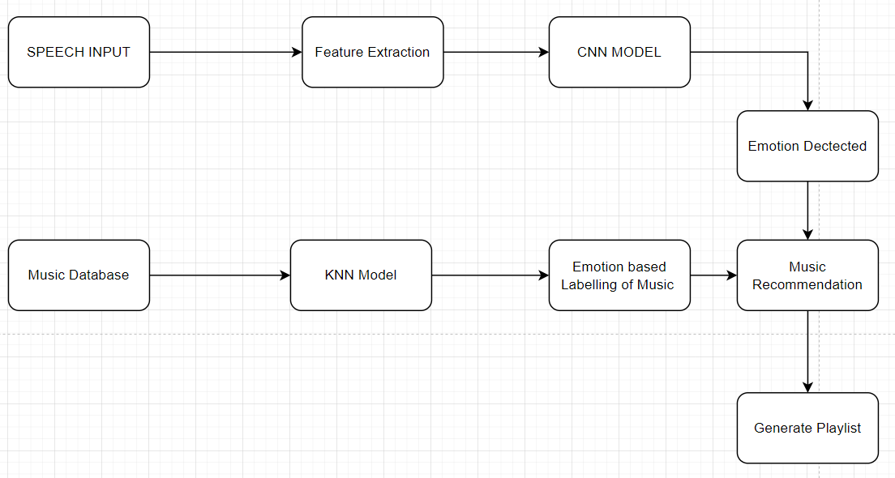

## **4.3 Use Cases**

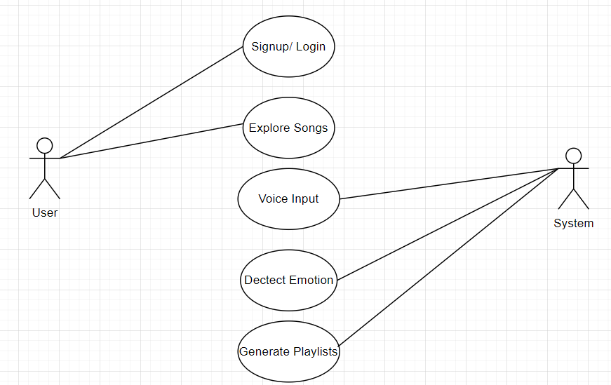

**User Registration and Sign In:**

|  |  |  |
| --- | --- | --- |
| **Use Case Name:** | Register Your Self and Sign In | |
| **ID:** | 1.1 | |
| **Actors Involved:** | Un-Registered User | |
| **Brief Description** | Actor register themselves by giving information whatever required, and then sign In. If already registered, then just sign in. | |
| **Pre-Conditions** | Not Registered or Not logged in | |
| **Post-Conditions** | Check Timeline | |
| **Normal Flow of Events:** | **Actor Action** | **System Response** |
| 1. Clicks the Register/Login button. 2. Fill the signup/login form. | 1. System displays the registration /login form. 2. System checks the information and register/login the user. |

**Homepage:**

|  |  |  |
| --- | --- | --- |
| **Use Case Name:** | Speech Emotion Recognition | |
| **ID:** | 1.2 | |
| **Actors Involved:** | Registered/Logged In user | |
| **Brief Description** | Homepage will offer the action to either go to their view playlist, search for music or continue playing where they left off | |
| **Pre-Conditions** | Logged In | |
| **Post-Conditions** | Library, Home, Search | |
| **Normal Flow of Events:** | **Actor Action** | **System Response** |
| Actor will select one of the three main options on the front page |  |

**Search:**

|  |  |  |
| --- | --- | --- |
| **Use Case Name:** | Speech Emotion Recognition | |
| **ID:** | 1.3 | |
| **Actors Involved:** | Actor / System | |
| **Brief Description** | Actor will input their voice for emotion recognition or they will search for music manually | |
| **Pre-Conditions** | Homepage | |
| **Post-Conditions** | Voice Input, Music Library | |
| **Normal Flow of Events:** | **Actor Action** | **System Response** |
| Actor will provide voice input. | 1. System will recognize the emotion from the voice input and based on that It will generate multiple playlist. |

**Recognize:**

|  |  |  |
| --- | --- | --- |
| **Use Case Name:** | Speech Emotion Recognition | |
| **ID:** | 1.4 | |
| **Actors Involved:** | System | |
| **Brief Description** | System will recognize type of emotion in voice. | |
| **Pre-Conditions** |  | |
| **Post-Conditions** |  | |
| **Normal Flow of Events:** | **Actor Action** | **System Response** |
|  | 1. System will voice and will check for emotions. |

**Recommend Playlist:**

|  |  |  |
| --- | --- | --- |
| **Use Case Name:** | Speech Emotion Recognition | |
| **ID:** | 1.5 | |
| **Actors Involved:** | System | |
| **Brief Description** | System will generate multiple playlists for user to select. | |
| **Pre-Conditions** | Voice input | |
| **Post-Conditions** | Playlists Generation | |
| **Normal Flow of Events:** | **Actor Action** | **System Response** |
|  | System will recommend multiple playlists according to detected emotion. |

**Generate Playlist:**

|  |  |  |
| --- | --- | --- |
| **Use Case Name:** | Speech Emotion Recognition | |
| **ID:** | 1.6 | |
| **Actors Involved:** | System | |
| **Brief Description** | System will generate multiple playlists for user to select. | |
| **Pre-Conditions** | Voice input | |
| **Post-Conditions** | Playlists Generation | |
| **Normal Flow of Events:** | **Actor Action** | **System Response** |
|  | 1. System will generate playlist. |

# Summary:

In this chapter, we have discussed the various diagrams used in the development of the SERMRS app, such as data flow diagrams, entity relationship diagrams, and use cases. These diagrams were essential in ensuring that our app met all the necessary requirements and provided a smooth user experience. During the development process, we prioritized testing and monitoring to identify and address any errors in the app. With the completion of the diagrams and implementation, we are confident that the SERMRS app will be a valuable tool for users, providing personalized music recommendations based on their emotions and preferences.

CHAPTER 5

# 5.1 Introduction:

This chapter discusses the design and development of the MoodTunes application, a music platform leveraging Speech Emotion Recognition (SER) technology to provide personalized playlists. We'll cover various facets including prototype design, frontend and backend development, database queries, the use of external libraries, and screenshots of our application demonstrating user requirements. We'll also delve into the source code of validation and discuss various functionalities within the system. The goal is to give a comprehensive understanding of the MoodTunes project, its innovative approach to personalized music recommendation, and the planning and execution involved in its creation.

# 5.2 Prototype Design:

**Project Title:** SEMRS  
 **Date:** 19/03/2023  
 **Screen Name:** Floating Screen/Splash Screen  
 **Screen:** < 1 of 9 >  
 **Link from screen:** Floating Screen  
 **Link to screen:** NIL  
 **Screen Description:** Is an initial window, Displays logo of the application.  
 **Screen time:** 1.5 seconds  
 **Functionality/Interactivity:** Enter Different Screen When user select option for functionality

**Screen Design**

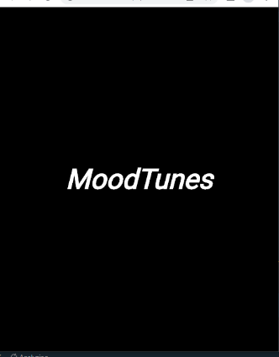:

**Background:** Black

**Audio:** Ding sound effect  
**Color scheme:** Black, white  
 **Video:** none  
 **Text attributes:** Centred

**Still images:** slide show

**Project Title:** SEMRS

**Date:** 19/03/2023  
  
 **Screen Name:** Login Screen/Home Activity  
 **Screen:** < 2 of 9 >  
 **Link from screen:** Floating Window  
 **Link to screen:** Take Picture window and login window  
 **Screen Description:**  
 Login with Registered Email or can select Third Party Social Services to Login, if not Registered Already then can Sign Up as well  
 **Functionality/Interactivity:** Enters the Home Activity and allows you to Login into the App, can also click on Sign Up button to register for an account or log in with third party services

**Screen Design:**

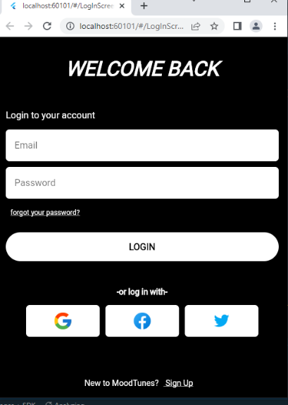

**Background:** Black

**Audio:** none  
 **Color scheme:** white, black, blue, cyan, red, green, yellow

**Video:** None  
 **Text attributes:** Default

**Still images:** None

**Project Title:** SEMRS  
 **Date:** 19/03/2023  
 **Screen Name**: Forget Password Activity  
 **Screen:** < 3 of 9 >  
 **Link from screen:** Main Window  
 **Link to screen**: Floating Window  
 **Screen Description:** Resets your Forgotten Password  
 **Functionality/Interactivity**: User can reset their password by getting a verification code to their email and setting a new password

**Screen Design:**

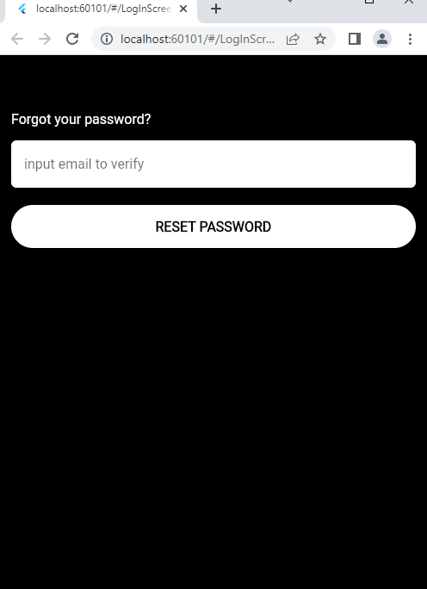

**Background:** Black and white

**Audio:** none  
 Color scheme: white, black

**Video:** None  
 Text attributes: Default

**Still images**: None

**Project Title:** SEMRS  
 **Date:** 19/03/2023  
 **Screen Name:** Sign Up Activity  
 **Screen:** < 4 of 9 >  
 **Link from screen:** Main Window  
 **Link to screen:** Floating Window  
 **Screen Description:** Registers your account for the application

**Functionality/Interactivity:** User can register and create new Account for the app, or use Third party services to register

**Screen Design:**

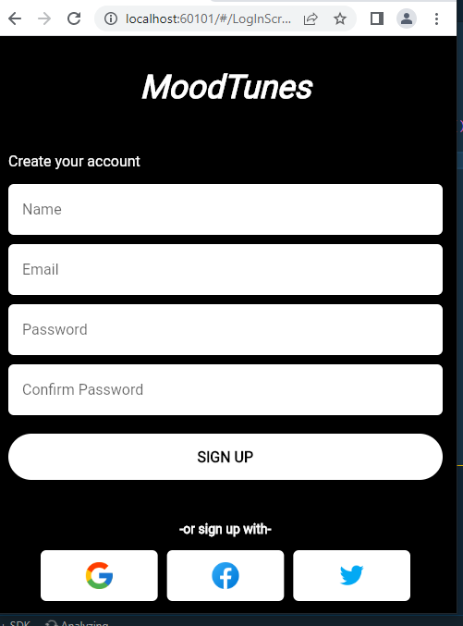

**Background:** Black

**Audio:** none  
 **Color scheme:** white, black

**Video:** None  
 **Text attributes:** Default

**Still images:** None

Project Title: SEMRS  
 Date: 19/03/2023  
 Screen Name: Voice Record Activity  
 Screen: < 5 of 9 >  
 Link from screen: Login Window  
 Link to screen: Floating Window  
 Screen Description: Allows you to speak into the microphone and records your voice  
 Functionality/Interactivity:

User Press and hold the logo to speak into the microphone and records their voice to detect emotion

Screen Design:

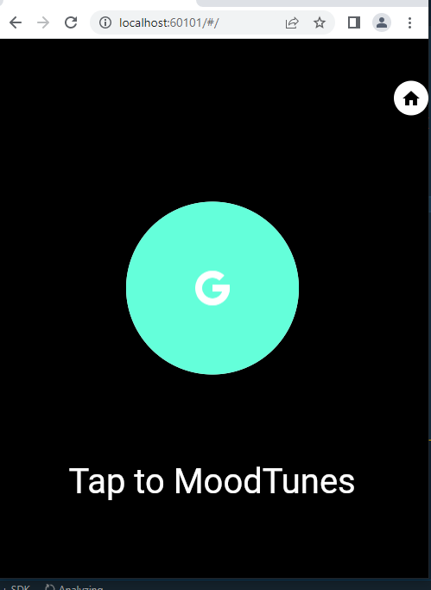

Background: Black

Audio: none  
 Color scheme: white, black, Cyan Green

Video: Animated Sphere  
 Text attributes: Default

 Still images: GoogleLogo.png

Project Title: SEMRS  
 Date: 19/03/2023  
 Screen Name: Play Music Activity  
 Screen: < 6 of 9 >  
 Link from screen: Voice Record Window  
 Link to screen: Floating Window  
 Screen Description: Suggests you some artists and playlist based on the analysis of your voice emotion  
 Functionality/Interactivity: User can select and play Music based on the recommended playlist and artist, User can change settings, view profile and navigate through different options in the navigation bar, can select genres

Screen Design:

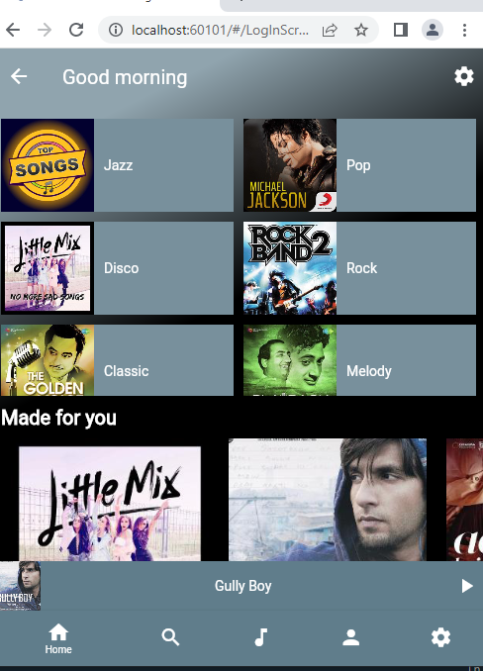

Background: Black and gradient

Audio: first recommended song  
 Color scheme: gray and white

Video: None  
 Text attributes: Default

 Still images: home.png, search.png, music.png, profile.png, settings.png

Project Title: SEMRS  
 Date: 19/03/2023  
 Screen Name: Activity  
 Screen: < 7 of 9 >  
 Link from screen: Play Music Activity  
 Link to screen: Floating Window  
 Screen Description: User can change settings in this screen according to their preference  
 Functionality/Interactivity: User can press the desired button to change the settings of their desired attribute, can tweak audio quality, change devices and other settings

Screen Design:

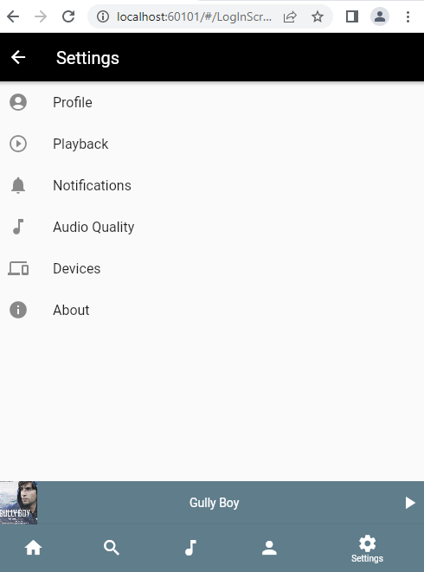

Background: Black and white

Audio: none  
 Color scheme: gray, black, white, gradient

Video: None  
 Text attributes: Default

 Still images: bell.png, playback.png, music.png, device.png, question.png, profile.png

Project Title: SEMRS  
 Date: 19/03/2023  
 Screen Name: Profile Activity  
 Screen: < 8 of 9 >  
 Link from screen: Play Music Window  
 Link to screen: Floating Window  
 Screen Description: User can change their profile and make playlist or save playlists based on the recommendation system here  
 Functionality/Interactivity: User can click on their saved recommended playlists here and play them, can also view their most played artist here and can change profile picture by clicking on the profile

Screen Design:

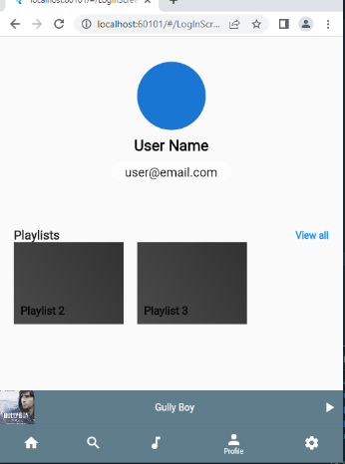

Background: Black

Audio: none  
 Color scheme: white, black, gradient, gray

Video: None  
 Text attributes: Default

 Still images: home.png, search.png, music.png, profile.png, settings.png

**Project Title**: SEMRS  
 **Date:** 19/03/2023  
 **Screen Name**: About Activity  
 **Screen:** < 9 of 9 >  
 **Link from screen:** About View Window  
 **Link to screen:** Floating Window  
 **Screen Description:** User can logout from their account

**Functionality/Interactivity:** User can click on the Logout button to log out of their account and return back to login screen

**Screen Design:**

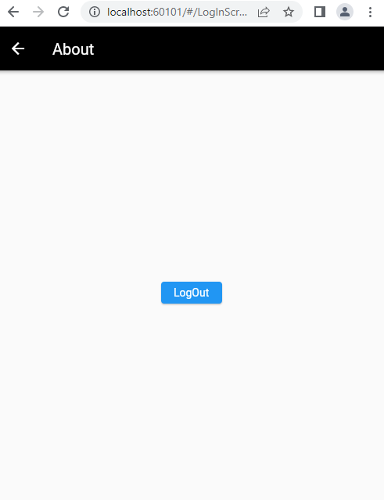

**Background:** gradient

**Audio:** none  
 **Color scheme:** white, black, gradient, gray, blue

**Video:** None  
 **Text attributes:** Default

**Still images:** None

CHAPTER 6

# 6.1 Introduction:

In this chapter, we discuss the test cases and usability tests conducted to ensure the proper functioning of the MoodTunes application and to validate its expected results. Testing plays a crucial role in verifying the system's functionality after the implementation phase. With the application's complexity and the reuse of code, a total of 16 test cases were developed. Each test case includes details such as the test case ID, description, test steps, expected result, actual result, pass or fail status, preparation date, running date, and testing date.

# 6.2 Test Cases:

### 6.2.1 Test Case 1:

|  |  |  |  |
| --- | --- | --- | --- |
| **Requirement Reference** | 1 | **Project Name** | Mood Tunes |
| **Test Case ID** | 1.1 | **Test Type** | UI |
| **Test Case Description** | This test case verifies the functionality of the splash screen, which appears when the application is launched | | |
| **Test Steps** | Verify that the splash screen appears immediately after launching the application. | | |
| **Expected Result** | The splash screen appears immediately after launching the application and displays the logo. | | |
| **Actual Result** | The splash screen appears immediately after launching the application and displays the logo. | | |
| **Pass/Fail** | Pass | | |
| **Date Prepared** | 3/3/2023 | | |
| **Date Run** | 3/3/2023 | | |
| **Prepared By** | Syed Saad Ahmed | | |
| **Tested By** | Muhammad Yaseen | | |

### 6.2.2 Test Case 2:

|  |  |  |  |
| --- | --- | --- | --- |
| **Requirement Reference** | 1 | **Project Name** | Mood Tunes |
| **Test Case ID** | 1.2 | **Test Type** | UI |
| **Test Case Description** | Verify that the user can navigate to the signup page if they click on the "Sign Up" button. | | |
| **Test Steps** | Open the login page and click on the signup button. | | |
| **Expected Result** | User taken to signup page upon clicking the button. | | |
| **Actual Result** | User taken to signup page upon clicking the button. | | |
| **Pass/Fail** | Pass | | |
| **Date Prepared** | 3/3/2023 | | |
| **Date Run** | 3/3/2023 | | |
| **Prepared By** | Syed Saad Ahmed | | |
| **Tested By** | Muhammad Yaseen | | |

### 6.2.3 Test Case 3

|  |  |  |  |
| --- | --- | --- | --- |
| **Requirement Reference** | 1 | **Project Name** | Mood Tunes |
| **Test Case ID** | 1.3 | **Test Type** | UI |
| **Test Case Description** | Verify that the sign up screen appears and users can enter their first name, last name, and email address in the respective fields. | | |
| **Test Steps** | Open the signup screen and provide all relevant details. | | |
| **Expected Result** | Sign up screen appears and details are filled without any error. | | |
| **Actual Result** | Sign up screen appears and details are filled without any error. | | |
| **Pass/Fail** | Pass | | |
| **Date Prepared** | 3/3/2023 | | |
| **Date Run** | 3/3/2023 | | |
| **Prepared By** | Syed Saad Ahmed | | |
| **Tested By** | Muhammad Yaseen | | |

### **6.2.4 Test Case 4:**

|  |  |  |  |
| --- | --- | --- | --- |
| **Requirement Reference** | 1 | **Project Name** | Mood Tunes |
| **Test Case ID** | 1.4 | **Test Type** | UI |
| **Test Case Description** | Verify that the user can submit the form by clicking on the "Sign Up" button. | | |
| **Test Steps** | Click the signup button after giving all the details on the sign up screen. | | |
| **Expected Result** | Submitting the sign-up form redirects the user to the login screen and displays a success message. | | |
| **Actual Result** | Submitting the sign-up form redirects the user to the login screen and displays a success message. | | |
| **Pass/Fail** | Pass | | |
| **Date Prepared** | 3/3/2023 | | |
| **Date Run** | 3/3/2023 | | |
| **Prepared By** | Syed Saad Ahmed | | |
| **Tested By** | Muhammad Yaseen | | |

### **6.2.5 Test Case 5:**

|  |  |  |  |
| --- | --- | --- | --- |
| **Requirement Reference** | 1 | **Project Name** | Mood Tunes |
| **Test Case ID** | 1.5 | **Test Type** | UI |
| **Test Case Description** | Verify the functionality of the user login feature, which allows users to access their account. | | |
| **Test Steps** | Verify that the login form is visible and contains the required fields: email/username and password. | | |
| **Expected Result** | The Login button should redirect the user to their account home screen. | | |
| **Actual Result** | The Login button redirect the user to their account home screen. | | |
| **Pass/Fail** | Pass | | |
| **Date Prepared** | 3/3/2023 | | |
| **Date Run** | 3/3/2023 | | |
| **Prepared By** | Syed Saad Ahmed | | |
| **Tested By** | Muhammad Yaseen | | |

### **6.2.6 Test Case 6:**

|  |  |  |  |
| --- | --- | --- | --- |
| **Requirement Reference** | 1 | **Project Name** | Mood Tunes |
| **Test Case ID** | 1.6 | **Test Type** | UI |
| **Test Case Description** | Verify that the user sees an error message if they enter an incorrect email address. | | |
| **Test Steps** | On the login page enter invalid email and password and then click the login button. | | |
| **Expected Result** | Shows error message “Invalid Email or password.” | | |
| **Actual Result** | Shows error message “Invalid Email or password.” | | |
| **Pass/Fail** | Pass | | |
| **Date Prepared** | 3/3/2023 | | |
| **Date Run** | 3/3/2023 | | |
| **Prepared By** | Syed Saad Ahmed | | |
| **Tested By** | Muhammad Yaseen | | |

### **6.2.7 Test Case 7:**

|  |  |  |  |
| --- | --- | --- | --- |
| **Requirement Reference** | 1 | **Project Name** | Mood Tunes |
| **Test Case ID** | 1.7 | **Test Type** | UI |
| **Test Case Description** | Verify the functionality of the home screen, which displays the user's music library and various features of the app. | | |
| **Test Steps** | Verify that the home screen is visible and displays the user's music library, including recently played, recommended, and saved songs/playlists. | | |
| **Expected Result** | The home screen should be visible and display the user's music library. | | |
| **Actual Result** | The home screen is visible and displays the user's music library. | | |
| **Pass/Fail** | Pass | | |
| **Date Prepared** | 3/3/2023 | | |
| **Date Run** | 3/3/2023 | | |
| **Prepared By** | Syed Saad Ahmed | | |
| **Tested By** | Muhammad Yaseen | | |

### **6.2.8 Test Case 8:**

|  |  |  |  |
| --- | --- | --- | --- |
| **Requirement Reference** | 1 | **Project Name** | Mood Tunes |
| **Test Case ID** | 1.8 | **Test Type** | Functionality |
| **Test Case Description** | To verify if the Speech Input page works as expected and has the option to navigate back to the Home page. | | |
| **Test Steps** | * Navigate to the Speech Input page. * Click on the microphone icon to enable speech input. * Provide a voice input. * Verify that the input is correctly recognized and a music playlist generated. | | |
| **Expected Result** | The speech detection feature and back to home page option should be working properly. | | |
| **Actual Result** | The speech detection feature and back to home page option are working properly. | | |
| **Pass/Fail** | Pass | | |
| **Date Prepared** | 3/3/2023 | | |
| **Date Run** | 3/3/2023 | | |
| **Prepared By** | Syed Saad Ahmed | | |
| **Tested By** | Muhammad Yaseen | | |

### **6.2.9 Test Case 9:**

|  |  |  |  |
| --- | --- | --- | --- |
| **Requirement Reference** | 1 | **Project Name** | Mood Tunes |
| **Test Case ID** | 1.9 | **Test Type** | UI |
| **Test Case Description** | To verify if the User Profile page is displayed when the User Profile button is clicked. | | |
| **Test Steps** | * Click on the User Profile button. * Verify that the User Profile page is displayed. * Check if all the user information is correctly displayed on the User Profile page. | | |
| **Expected Result** | The User Profile button on the Home page should navigate to the user's profile and display all the information. | | |
| **Actual Result** | The User Profile button on the Home page is working and navigates to the user's profile and displays all the information. | | |
| **Pass/Fail** | Pass | | |
| **Date Prepared** | 3/3/2023 | | |
| **Date Run** | 3/3/2023 | | |
| **Prepared By** | Syed Saad Ahmed | | |
| **Tested By** | Muhammad Yaseen | | |

### **6.2.10 Test Case 10:**

|  |  |  |  |
| --- | --- | --- | --- |
| **Requirement Reference** | 1 | **Project Name** | Mood Tunes |
| **Test Case ID** | 1.10 | **Test Type** | UI |
| **Test Case Description** | To verify if the Search Bar is working properly and displaying the expected songs in results. | | |
| **Test Steps** | * Click on the Search Bar. * Enter the name of an artist, album, or song. * Verify that the search results are displayed correctly. | | |
| **Expected Result** | Clicking on the search option and entering name should display the selected song, album, or artist correctly. | | |
| **Actual Result** | Clicking on one of the search results displays the selected song, album, or artist correctly. | | |
| **Pass/Fail** | Pass | | |
| **Date Prepared** | 3/3/2023 | | |
| **Date Run** | 3/3/2023 | | |
| **Prepared By** | Syed Saad Ahmed | | |
| **Tested By** | Muhammad Yaseen | | |

### **6.2.11 Test Case 11:**

|  |  |  |  |
| --- | --- | --- | --- |
| **Requirement Reference** | 1 | **Project Name** | Mood Tunes |
| **Test Case ID** | 1.11 | **Test Type** | Functionality |
| **Test Case Description** | To verify if the app is able to detect the user's emotion from their voice input and recommend appropriate songs and playlists. | | |
| **Test Steps** | * Navigate to the Speech Input page and provide voice input.. * Verify that the app is able to detect the user's emotion and able to recommend appropriate songs and generate playlists based on the detected emotion. | | |
| **Expected Result** | The app should recommend songs and playlists based on the detected emotion. | | |
| **Actual Result** | The app recommends songs and playlists based on the detected emotion. | | |
| **Pass/Fail** | Pass | | |
| **Date Prepared** | 3/3/2023 | | |
| **Date Run** | 3/3/2023 | | |
| **Prepared By** | Syed Saad Ahmed | | |
| **Tested By** | Muhammad Yaseen | | |

### **6.2.12 Test Case 12:**

|  |  |  |  |
| --- | --- | --- | --- |
| **Requirement Reference** | 1 | **Project Name** | Mood Tunes |
| **Test Case ID** | 1.12 | **Test Type** | Functionality |
| **Test Case Description** | To verify if the app is able to play a song successfully when requested by the user. | | |
| **Test Steps** | * Click on the song to play it. * Verify that the song starts playing. | | |
| **Expected Result** | The app should be able to play the song successfully. | | |
| **Actual Result** | The app plays the song successfully. | | |
| **Pass/Fail** | Pass | | |
| **Date Prepared** | 3/3/2023 | | |
| **Date Run** | 3/3/2023 | | |
| **Prepared By** | Syed Saad Ahmed | | |
| **Tested By** | Muhammad Yaseen | | |

### **6.2.13 Test Case 13:**

|  |  |  |  |
| --- | --- | --- | --- |
| **Requirement Reference** | 1 | **Project Name** | Mood Tunes |
| **Test Case ID** | 1.13 | **Test Type** | Functionality |
| **Test Case Description** | To verify if the app is able to create a playlist successfully when requested by the user. | | |
| **Test Steps** | * Navigate to the "Create Playlist" option. * Provide a name for the new playlist. * Add songs to the playlist. * Save the playlist. * Navigate to the newly created playlist. * Verify that the playlist name is correct. | | |
| **Expected Result** | The app creates the playlist successfully. | | |
| **Actual Result** | The app creates the playlist successfully. | | |
| **Pass/Fail** | Pass | | |
| **Date Prepared** | 3/3/2023 | | |
| **Date Run** | 3/3/2023 | | |
| **Prepared By** | Syed Saad Ahmed | | |
| **Tested By** | Muhammad Yaseen | | |

### **6.2.14 Test Case 14:**

|  |  |  |  |
| --- | --- | --- | --- |
| **Requirement Reference** | 1 | **Project Name** | Mood Tunes |
| **Test Case ID** | 1.14 | **Test Type** | UI |
| **Test Case Description** | To verify, users can add/save a song to an existing playlist. | | |
| **Test Steps** | * Search for the desired song using the search bar or browse the available songs. * Click on the "Add" or "Save" button next to the selected song. * Verify that the song has been added to the playlist. | | |
| **Expected Result** | The user should be able to add a song to an existing playlist successfully. | | |
| **Actual Result** | The user can add the song to the existing playlist successfully. | | |
| **Pass/Fail** | Pass | | |
| **Date Prepared** | 3/3/2023 | | |
| **Date Run** | 3/3/2023 | | |
| **Prepared By** | Syed Saad Ahmed | | |
| **Tested By** | Muhammad Yaseen | | |

### **6.2.15 Test Case 15:**

|  |  |  |  |
| --- | --- | --- | --- |
| **Requirement Reference** | 1 | **Project Name** | Mood Tunes |
| **Test Case ID** | 1.15 | **Test Type** | UI |
| **Test Case Description** | To verify if the user is able to delete a song from a playlist or delete the entire playlist successfully. | | |
| **Test Steps** | * Go to the playlist or song. * Click on the delete button. * Verify that the playlist has been deleted successfully. | | |
| **Expected Result** | The app should be able to delete a song from the playlist or playlist successfully. | | |
| **Actual Result** | The app deletes the song from the playlist /playlist successfully. | | |
| **Pass/Fail** | Pass | | |
| **Date Prepared** | 3/3/2023 | | |
| **Date Run** | 3/3/2023 | | |
| **Prepared By** | Syed Saad Ahmed | | |
| **Tested By** | Muhammad Yaseen | | |

### **6.2.16 Test Case 16:**

|  |  |  |  |
| --- | --- | --- | --- |
| **Requirement Reference** | 1 | **Project Name** | Mood Tunes |
| **Test Case ID** | 1.16 | **Test Type** | UI |
| **Test Case Description** | verify if the app is able to logout the user successfully when requested. | | |
| **Test Steps** | * Click on the logout button. * Verify that the app is navigated to the login page. | | |
| **Expected Result** | The app should be able to log out the user successfully. | | |
| **Actual Result** | The app logs out the user successfully. | | |
| **Pass/Fail** | Pass | | |
| **Date Prepared** | 3/3/2023 | | |
| **Date Run** | 3/3/2023 | | |
| **Prepared By** | Syed Saad Ahmed | | |
| **Tested By** | Muhammad Yaseen | | |

## 6.3 Summary

In this chapter, the focus was on test cases for software implementation, covering both minor and major functionalities. The testing phase is crucial to ensure that the system works correctly, and this chapter has discussed various test cases, including usability tests. The code reusability of the application helped to keep the total number of test cases at 16. Each test case includes a reference to the project and application names, along with detailed attributes, such as test case ID, description, steps, expected result, pass/fail status, preparation date, running date, and the date on which it was tested. This chapter provides readers with a thorough understanding of the test cases used to test the software and to ensure that it meets the expected requirements.

CHAPTER 7

## **7.1 Introduction**

This chapter will summarize the final year of our project SERMRS (Speech Emotion Recognition based Music Recommendation System). Our project is a machine learning-based application that uses human speech to detect emotions and recommend music based on the user's emotions and personal preferences. This chapter aims to provide an overview of the work completed, challenges faced, limitations of the system, and future work for our project.

We have designed SERMRS to provide a personalized music experience to the users based on their emotions and personal preferences. The system detects the user's emotion through their speech and recommends music accordingly. Our project has immense potential for future work that can enhance the user experience and make it more effective.

This chapter will discuss the major and minor work completed on the project. We will also highlight the limitations of the system to help the users better understand the application. Moreover, we will present an overview of the future work that can be done to improve SERMRS. This includes adding new features, enhancing the usability of the application, and creating a more personalized experience for the users.

Our project has the potential to revolutionize the way people listen to music, and we believe that with continuous development and improvements, it can become one of the most popular applications in the music industry.

## **7.2 System Limit and challenges**

There are several limitations and challenges that have been identified during the development of the Speech Emotion Recognition based Music Recommendation System (SERMRS).

One of the main limitations of the system is the accuracy of the emotion detection algorithm. While the algorithm has been trained on a large dataset, it may not always accurately detect the correct emotion based on the user’s speech. This can lead to incorrect music recommendations, which may not accurately reflect the user’s mood.

Another challenge is the availability and quality of the music data. The system requires a large and diverse dataset of music that is properly labeled and classified by genre and emotion. While there are several publicly available datasets, they may not be sufficient for the needs of the system. Additionally, the quality of the music data may also impact the accuracy of the music recommendations.

The system also faces challenges related to user privacy and data protection. As the system requires access to the user’s speech data, there is a need to ensure that the user’s privacy is protected and that the data is stored and processed securely.

Finally, there may be technical challenges related to the implementation and integration of the system with other platforms and devices. The system must be designed to work seamlessly with different operating systems and devices, which may require additional development and testing efforts.

**The challenges we faced during the development of the project were:**

Finding labelled music dataset so that it would be easier for us to make clusters of the music data based on their emotion.

The other major challenge that we faced during development was the integration using restful api. It was a completely new concept and had to learn it from scratch.

## **7.3 Future Wrok**

There are several areas of future work that can be considered for SERMRS. The first area of future work involves the expansion of the emotion recognition system. While the current system is effective in recognizing basic emotions, there is room for improvement to recognize more complex emotions such as confusion, surprise, or shame. This can be achieved by using more advanced machine learning algorithms or by adding more features to the current system.

Another area of future work is the enhancement of the music recommendation system. Currently, the system recommends music based on the user's emotion and personal preferences, but there is potential for the system to learn from the user's feedback and refine the recommendations over time. The system can also be expanded to include more diverse genres of music and consider other factors such as the time of day, weather, or activity.

Furthermore, the user interface and user experience can be improved to make the app more intuitive and user-friendly. This can be achieved by conducting user research and testing to identify areas of improvement and implementing changes based on the feedback received.

Lastly, the app can be expanded to include additional features such as social sharing, personalized playlists, and integration with other music platforms. This will make the app more engaging and increase its value to the users

# 7.4 Conclusion

In conclusion, the Speech Emotion Recognition based Music Recommendation System project has successfully implemented a machine learning-based system that detects emotions in human speech and recommends music based on the emotion and the user's personal preferences. The project has achieved its objectives by curating a personalized playlist for users based on their emotions and music preferences.

During the project, various challenges and limitations were encountered, such as data acquisition and processing, as well as the limitations of the machine learning algorithms used in the project. Future work can be done to overcome these limitations and improve the performance of the system, such as using more advanced machine learning algorithms, increasing the dataset size, and enhancing the user interface.

The future work section also highlights the potential for the system to be applied in various fields, such as mental health and therapy, and the possibility of expanding the system to incorporate other types of media, such as video and images, to further enhance the personalized recommendations.

Overall, the SERMRS project has demonstrated the potential of machine learning-based systems in curating personalized music recommendations based on human emotion and preferences, and we hope that this project will inspire further research and development in this field.

REFERENCES

1. Choi, H., Lee, J. H., & Lee, J. (2019). Contextual emotion recognition from speech signals: A review. IEEE Access, 7, 18499-18517.
2. Koren, Y., Bell, R., & Volinsky, C. (2009). Matrix factorization techniques for recommender systems. Computer, 42(8), 30-37.
3. Liang, Y., & Fu, G. (2018). A hybrid filtering approach for music recommendation with implicit feedback. Knowledge-Based Systems, 140, 139-150.
4. McFee, B., Raffel, C., Liang, D., Ellis, D. P., McVicar, M., Battenberg, E., ... & Pande, S. (2015). librosa: Audio and music signal analysis in python. In Proceedings of the 14th python in science conference (pp. 18-25).
5. Schedl, M., & Wieser, C. (2014). Exploring the limits of collaborative filtering-based music recommendation. User Modeling and User-Adapted Interaction, 24(1-2), 165-204.
6. Yang, C., & Hu, W. (2018). A survey of speech emotion recognition: Features, classification schemes, and databases. Speech Communication, 107, 77-89.
7. Cunningham, S. J., & Adomavicius, G. (2018). Understanding user preferences through explicit and implicit feedback for music recommendation. ACM Transactions on Interactive Intelligent Systems (TiiS), 8(3), 1-31.
8. Lam, B. Y. K., Chen, K., Lai, C. F., & Hsu, W. (2017). Deep learning for mobile multimedia: A survey. ACM Transactions on Multimedia Computing, Communications, and Applications (TOMM), 13(3), 1-21.
9. Li, J., & She, J. (2019). A review of deep learning-based music recommendation systems. ACM Computing Surveys (CSUR), 52(3), 1-34.

Zhu, S., Zhang, X., & Wang, J. (2019). Emotion-based music recommendation: A survey. Journal of Ambient Intelligence and Humanized Computing, 10(8), 3157-3168.

<https://www.kaggle.com/code/shivamburnwal/speech-emotion-recognition?scriptVersionId=34958802&cellId=39>

APPENDIX

# Business Canvas:

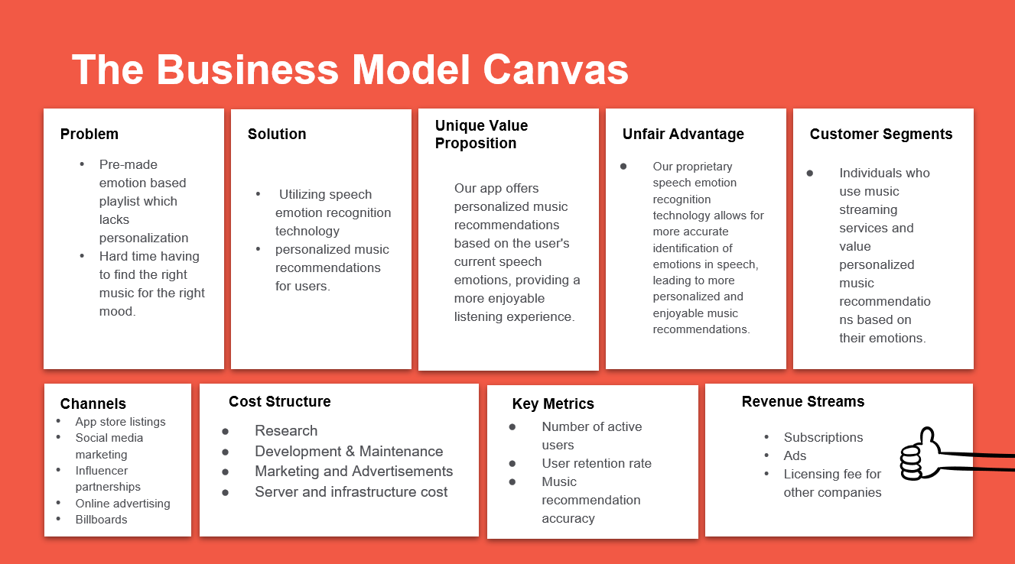

User Guide: MoodTunes App

Welcome to MoodTunes! This user guide will provide you with the necessary information to navigate and utilize the features of the MoodTunes app, a speech emotion recognition-based music recommendation system. Let's get started!

Table of Contents:

1. Introduction
2. Getting Started

2.1 Installation

2.2 Account Creation

1. Home Screen

3.1 Search Bar

3.2 Microphone Icon

1. Emotion Recognition
2. Library

5.1 Playlist Management

1. Settings

6.1 Account Settings

6.2 App Preferences

1. Troubleshooting
2. Frequently Asked Questions
3. Conclusion

## Introduction:

MoodTunes is an innovative app designed to enhance your music listening experience by recommending playlists based on your current emotions. Using speech emotion recognition technology, MoodTunes analyses your voice to identify emotions and generates personalized music suggestions. Whether you're feeling happy, sad, calm, or excited, MoodTunes has the perfect playlist for every mood.

# Getting Started:

* 1. Installation: To begin using MoodTunes, follow these steps:
* Visit the app store on your device (e.g., Google Play Store, Apple App Store).
* Search for "MoodTunes" in the app store search bar.
* Tap on the MoodTunes app icon and select "Install" to download and install the app on your device.
* Once the installation is complete, you can find the MoodTunes app on your device's home screen.

2.2 Account Creation:

* Open the MoodTunes app on your device.
* If you are a new user, tap on the "Create Account" button to register.
* Provide the required information, such as your name, email address, and password.
* Follow the on-screen prompts to complete the account creation process.
* If you already have an account, tap on the "Log In" button and enter your credentials to access your account.

1. Home Screen

Upon launching the MoodTunes app, you will be directed to the home screen. The home screen serves as a hub for accessing various features of the app.

3.1 Search Bar: At the top of the home screen, you will find a search bar. Use this search bar to find specific songs, artists, or albums within the MoodTunes music library. Simply enter your search query and tap the "Search" button to view the results.

3.2 Microphone Icon: Next to the search bar, you will see a microphone icon. Tapping on this icon will take you to the Emotion Recognition screen, where you can use your voice to analyse your current emotions and receive personalized music recommendations. Speak clearly into the microphone and follow the on-screen instructions to proceed.

1. Emotion Recognition:

The Emotion Recognition feature of MoodTunes utilizes speech analysis to identify your current emotions. Follow these steps to use this feature:

* Tap on the microphone icon on the home screen.
* Speak naturally into the device's microphone, expressing your current emotions or thoughts.
* MoodTunes will analyze your voice and identify the dominant emotion.
* Based on the identified emotion, MoodTunes will generate a personalized playlist for you to enjoy.

1. Library:

The library section of the app stores your previously created playlists and allows you to manage them.

5.1 Playlist Management:

* Access the Library section from the home screen.
* Here, you will find all your saved playlists.
* Tap on a playlist to view its contents.
* From the playlist view, you can play the entire playlist, add or remove songs, or rearrange the song order according to your preferences.

1. Settings: The Settings section allows you to customize various aspects of the MoodTunes app.

6.1 Account Settings:

* In the Settings menu, you can manage your account details, such as name, email address, and password.
* Update your account information as needed and tap "Save" to apply the changes.

6.2 App Preferences:

* In the Settings menu, you can configure app preferences, including notification settings, playback options, and theme customization.
* Customize these preferences according to your preferences to enhance your MoodTunes experience.

## Troubleshooting

If you encounter any issues while using MoodTunes, try the following troubleshooting steps:

* Ensure that you have a stable internet connection.
* Check for app updates in the app store and install any available updates.
* Restart your device and relaunch the MoodTunes app.
* If the problem persists, contact MoodTunes support for further assistance.

.

## Conclusion:

Congratulations! You have completed the MoodTunes user guide. We hope this guide has provided you with a comprehensive understanding of the app's features and functionality. Enjoy exploring your emotions through music with MoodTunes! If you have any further questions or require assistance, please refer to the app's support resources or contact our customer support team.